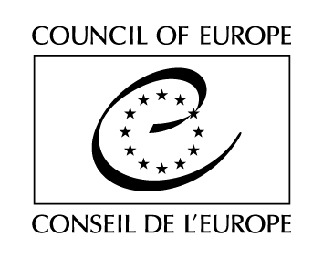

Strasbourg, .. February 2019 GT-ED(2019)OJ1

EUROPEAN COMMITTEE ON DEMOCRACY AND GOVERNANCE
(CDDG)

WORKING GROUP ON E-DEMOCRACY
(GT-ED)

DRAFT AGENDA

Opening of the meeting: Thursday 14 March 2019 at 9.30 am
Close of the meeting: Friday 15 March 2019 at 6.00 pm
Strasbourg, Council of Europe, Agora, Room …

1. | Opening of the meeting by the Secretariat
2. | Adoption of the agenda
3. | Meeting report of the first meeting of the working group | [GT-ED(2018)3]
4.  4.1  4.2 | Guidelines on e-democracy in the form of a toolkit  Working paper  - Presentation of the paper prepared by the expert;  - Exchange of views and drafting proposals by the working group  E-democracy initiatives:  - Presentation of case-studies in member States  - Lessons learned | [GT-ED(2019)2]
5. | Review meeting on Recommendation CM/Rec(2017)5 on standards for e-voting: preliminary exchange of views | [GT-ED(2019)3]
6. | Conclusions
7. | Other business
8. | Date and place of the next meeting  Strasbourg, 12-13 September 2019

